|  |  |
| --- | --- |
| **Assignment No.** | 1 |
| **Name** | Nithish Bharathwaj K R |
| **Registration No.** | 195001072 |
| **Team No.** | PNT2022TMID53102 |

**Question-1:**

**Create registration page in html with username, email, and phone number and by using POST method display it in next html page.**

**index.html**

<!DOCTYPE html>

<html>

<head>

<meta charset="utf-8">

<meta name="viewport" content="width=device-width, initial-scale=1">

<title>Registration</title>

<link rel="stylesheet" href="{{ url_for('static',filename='styles/index.css') }}">

</head>

<body>

<center>

<br><br>

<h1>Registration</h1><br>

<form action="{{ url_for('result') }}" method="post">

<table>

<tr>

<td>

<label>Name</label>

</td>

<td>

: <input type="text" class="name-input name mb-3" id="name" name="name">

</td>

</tr>

<tr>

<td>

<label>Email</label>

</td>

<td>

: <input type="email" class="name-input name mb-3" id="email" name="email">

</td>

</tr>

<tr>

<td>

<label>Mobile</label>

</td>

<td>

: <input type="number" class="name-input name mb-3" id="mobile" name="mobile">

</td>

</tr>

</table>

<br><br>

<input class="btn btn-outline-primary" type="submit" value="Submit">

</form>

</center>

</body>

</html>

**result.html**

<!DOCTYPE html>

<html>

<head>

<meta charset="utf-8">

<meta name="viewport" content="width=device-width, initial-scale=1">

<title>Profile</title>

<link rel="stylesheet" href="{{ url_for('static',filename='styles/index.css') }}">

</head>

<body>

<center>

<br><br>

<h1>Welcome !!!</h1>

<br>

<form action="{{ url_for('result') }}" method="post">

<table>

<tr>

<h3>Name : {{ name }}<br></h3>

</tr>

<tr>

<h3>Email : {{ email }}<br></h3>

</tr>

<tr>

<h3>Mobile : {{ mobile }}<br></h3>

</tr>

</table>

<br><br>

</form>

</center>

</body>

</html>

**app.py**

from flask import *;

import os

app = Flask(__name__)

@app.route('/', methods=['GET', 'POST'])

def home():

if request.method == 'POST':

name = request.form["name"]

email= request.form["email"]

mobile = request.form["mobile"]

return redirect(url_for('result', name=name, email=email, mobile=mobile))

return render_template('index.html')

@app.route("/result", methods=['GET', 'POST'])

def result():

name = request.form.get('name')

email= request.form.get('email')

mobile = request.form.get('mobile')

return render_template('result.html', name=name, email=email, mobile=mobile)

if __name__ == "__main__":

app.run(debug=True, port=2807)

**OUTPUT:**

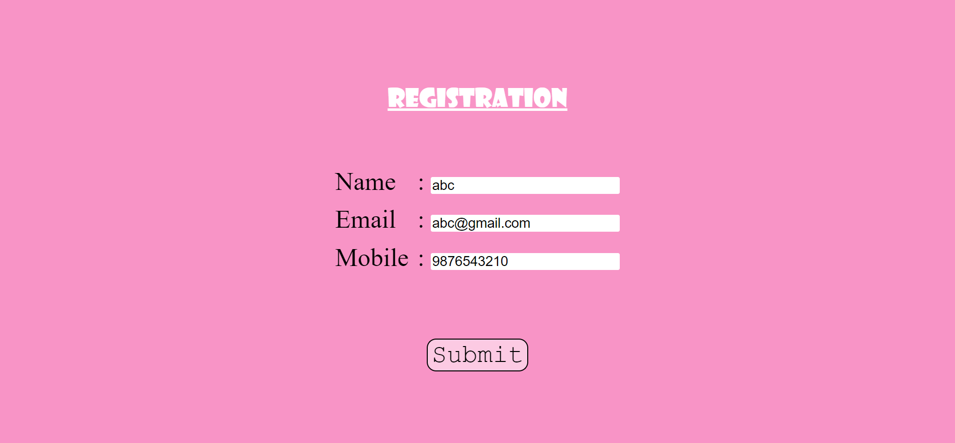



**Question-2:**

**Develop a Flask program which should contain at least 5 packages used from pypi.org**